Assignment -3

Bucket And Watson assistant

|  |  |
| --- | --- |
| Assignment Date | 26 October 2022 |
| Student Name | MEGALOSHINI S |
| Student Roll Number | 713319CS075 |
| Maximum Marks | 2 Marks |

Questions:

1. Create a Bucket in IBM object storage.

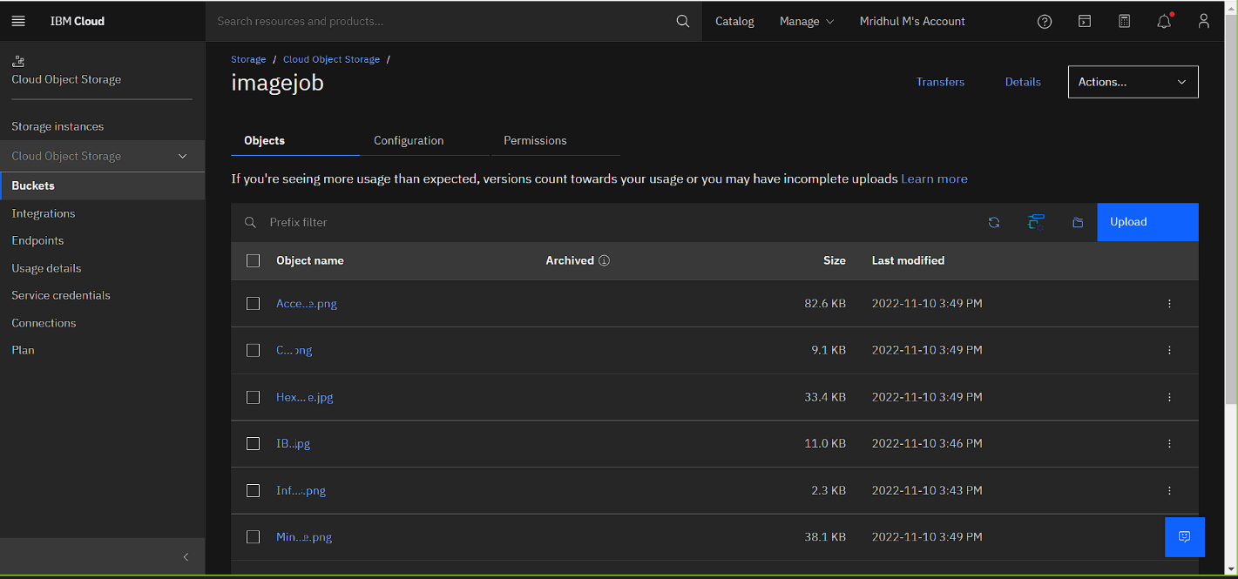

1. Upload 5 images to IBM object storage and make it public. write html code to displaying all the 5 images.

Index.html

|  |
| --- |
| {%for i in range(0, len)%}    <div class="jobs-container">      <div class="job">        <div class="job-preview">          <br>          <center><img class="img" src="{{job_image[i]}}" width="80" height="50" ></center>          </div>        <div class="job-info">             <h2>{{job_name[i]}} - {{job_location[i]}} ({{job_salary[i]}})</h2>           <h2>{{job_role[i]}}</h2>          <h4>Contact: {{job_number[i]}}</h4>            <button class="btn">REGISTER</button>        </div>      </div>    </div>      {%endfor%} |

1. Upload a CSS page to the object storage and use the same page in your HTML code.

Output:

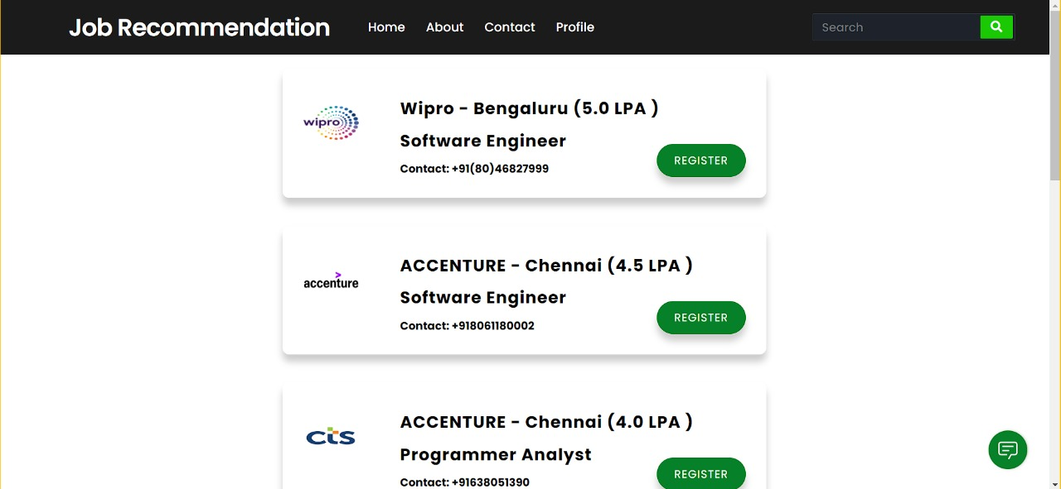

4.Design a chatbot using IBM Watson assistant for hospital. Ex: User comes with query to know the branches for that hospital in your city. Submit the web URL of that chat bot as a assignment.

Url :- [chatbot link](https://web-chat.global.assistant.watson.appdomain.cloud/preview.html?backgroundImageURL=https%3A%2F%2Feu-gb.assistant.watson.cloud.ibm.com%2Fpublic%2Fimages%2Fupx-2187bdc6-3463-4336-a0e5-105ac4d979db%3A%3A31897cd3-e620-4527-80d8-c93d7c618899&integrationID=fd3649a9-27f7-43a9-96c0-5ca4d5bbf885&region=eu-gb&serviceInstanceID=2187bdc6-3463-4336-a0e5-105ac4d979db) <- click

Image-

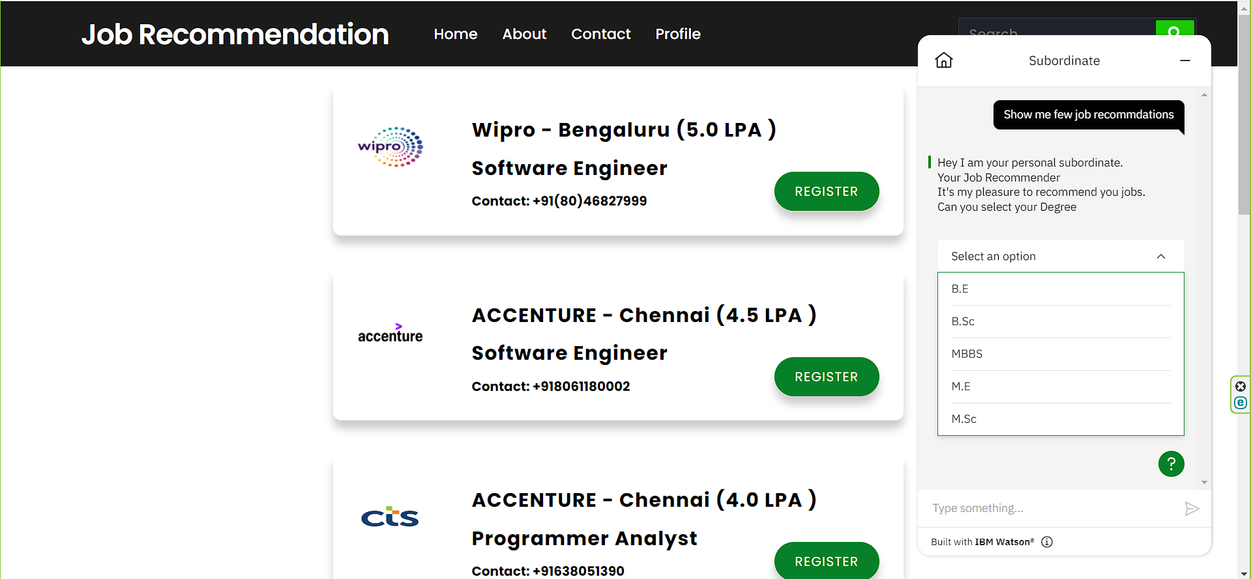

1. Create Watson assistant service with 10 steps and use 3 conditions in it. Load that script in HTML page

